Exp.No:39
39. Vehicle Detection in a Video frame using OpenCV .

Aim:
To detect vehicles in video frames using OpenCV.
Procedure:
- Open the vehicle video.
- Read the video frame by frame.
- Convert each frame to grayscale.
- Apply a background subtractor.
- Find moving objects using contours.
- Draw rectangles around detected objects.
- Display the video.
- Stop when q is pressed.
Program:
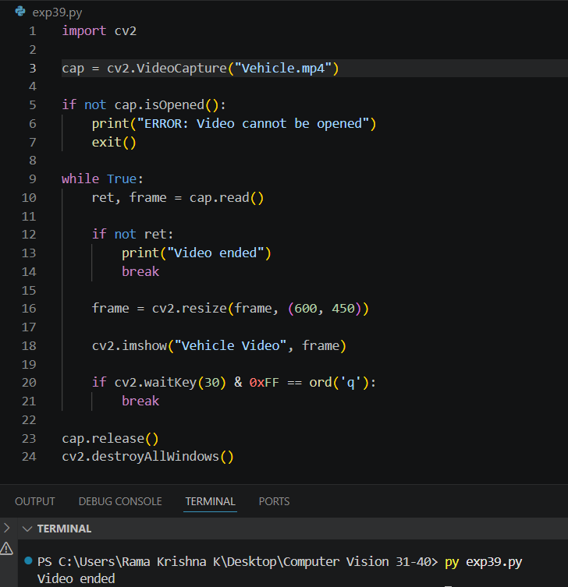
Output:
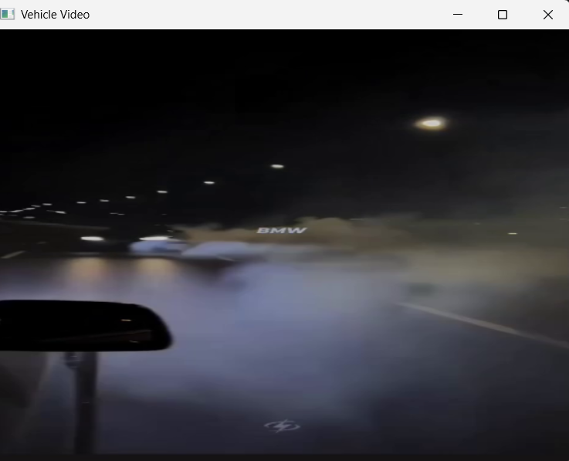

Result:
The vehicles in the video frames were successfully detected using OpenCV.

